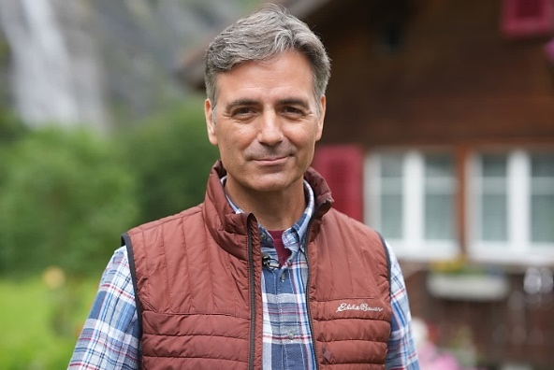

Social Media &Publicity Links
- Real Road Adventures website: www.RealRoadTV.com
  - Series web portal
  - Press releases, bios, photos
  - Video clips, transcripts, updates on all six Real Road episodes
  - Links to tourist offices, museums, historic sites, hotels
  - On-line ordering for Real Road Adventures DVDs, or order desk at 800.866.7425

  - Real Road Adventures trailer on YouTube: https://www.youtube.com/user/SmartTravelsTV/videos

  - Real Road Adventures 30 second promo on YouTube: https://www.youtube.com/user/SmartTravelsTV/videos

  - Real Road Adventures Facebook: https://www.facebook.com/realadventurestv/

  - Real Road Adventures Instagram: https://www.instagram.com/realadventurestv/

  - Real Road Adventures Twitter: https://twitter.com/RealAdventureTV

  - Real Road Adventures Photos for Social Media Dropbox, cut and paste this link into a browser: https://www.dropbox.com/sh/wtjq7kcml0pfyrr/AAAt_wzQE3UxaXHEEKF30bL8a?dl=0

  - Real Road Adventures Video Clips for Social Media Dropbox, cut and paste this link into a browser: https://www.dropbox.com/sh/ofjssaha0jxt44u/AADMjjFv3hVLCFOJvQi7Q67ra?dl=0

  - Contact: John Givens, Small World Productions
johngivens@travelsmallworld.com
206.329.7167
- Real Road Adventures is distributed nationally by American Public Television Exchange

- Real Road Adventures Co-Producer/Presenting Station: KCTS/Seattle, Cascade Public Media

- Other Small World series: Real Rail Adventures with Jeff Wilson 4/60 Smart Travels with Rudy Maxa 65/30 Adventures with Purpose with Richard Bangs12/60 America’s Historic Trails with Tom Bodett 13/30 Travels in Mexico and the Caribbean with Shari Belafonte 13/30 Travels in Europe with Rick Steves 52/30
- Major corporate support for Real Road Adventures is provided by Volkswagen.
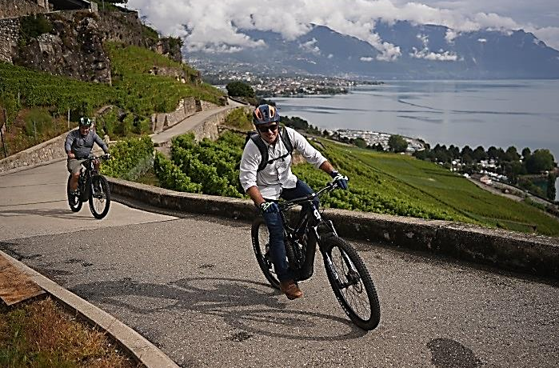

SUGESTED TWEETS: Samples may be cut-and-pasted into station Twitter feed. Please insert correct time for your broadcast and a photo or clip from the Dropbox links below.
PREMIERE! Tonight [Your Air Time] Join Real Road Adventures host Jeff Wilson as he navigates the “E-Grand Tour of Switzerland” in a battery powered electric car to explore the scenic wonders, multicultural heritage, and sustainable resources of Switzerland and Liechtenstein. #realroadadventures #ev #travel
[Your Air Time] Join “Real Road” host Jeff Wilson on the “E-Grand Tour of Switzerland” in the freedom, safety, and ease of a battery powered car. All along the way Jeff discovers how Switzerland and Liechtenstein are conserving their natural beauty and fragile ecosystems. #realroadadventures
WATCH! Tonight [Your Air Time] Host Jeff Wilson models a stress-free, illuminating, multi-country, multi-cultural European road trip by battery powered car. Celebrate the stunning sights with Jeff on Real Road Adventures: Switzerland and Liechtenstein tonight on [Your Station] #realroadadventures #ev #travel
TONIGHT! [Your Air Time] Charge up your electric car, your e-bike and your appetite for environmentally friendly European sightseeing tonight on [Your Station]. “Real Road Adventures: Switzerland and Liechtenstein with Jeff Wilson” tonight at [Your Time.]. #realroadventures #ev #travel
PHOTOS FOR SOCIAL MEDIA: cut and paste this link into a browser
https://www.dropbox.com/sh/wtjq7kcml0pfyrr/AAAt_wzQE3UxaXHEEKF30bL8a?dl=0

VIDEO CLIPS FOR SOCIAL MEDIA: cut and paste this link into a browser
https://www.dropbox.com/sh/ofjssaha0jxt44u/AADMjjFv3hVLCFOJvQi7Q67ra?dl=0

Click a link to open a folder of photos or video clips. Select a file and double click to open. To download the file, click the download arrow [ ↓ ] at top center of the page.

Major corporate support for Real Road Adventures is provided by Volkswagen.

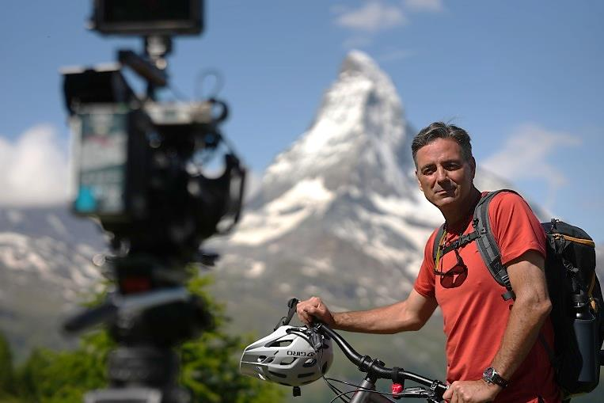

SUGESTED FACEBOOK POSTS: Samples may be cut-and-pasted into station feed. Please insert your call letters or channel, the day/time for your broadcast, and a photo or video clip from the Dropbox links below.

TONIGHT [insert time] on [station], Real Road Adventures host Jeff Wilson navigates the “E-Grand Tour of Switzerland” in a battery powered electric car and discovers the freedom, safety, and convenience of European travel by EV. All along the way, Jeff marvels at how Switzerland and Liechtenstein are conserving their natural beauty and fragile ecosystems. For intoxicating, eco-friendly adventure, Jeff plunges into the great outdoors for kayaking, e-biking, white-water rafting and more. Please tag: https://www.facebook.com/realadventurestv/

WATCH! [Insert day/time] on [station]. Real Road Adventures host Jeff Wilson discovers the ease, freedom, and safety of a battery powered car as he explores the “E-Grand Tour of Switzerland.” Along the way, Jeff checks out environmentally friendly accommodations – from rustic country inns to award-winning luxury hotels with sustainable practices. And he seeks out opportunities for retreat and self-discovery, on the road less traveled, visiting hidden villages and befriending locals who have discovered the secrets to work-life balance.
Please tag: https://www.facebook.com/readadventurestv/

TONIGHT [insert day/time] on [station]. Jeff Wilson models a stress-free, illuminating, multi-country, multi-cultural European road trip by battery powered car on Real Road Adventures. Join Jeff as he navigates the “E-Grand Tour of Switzerland” and discovers the freedom, safety, and convenience of European travel by EV. For intoxicating, eco-friendly adventure, Jeff tries his hand at kayaking, e-biking, and white-water rafting. And he seeks out opportunities for retreat and self-discovery, on the road less traveled, visiting hidden villages and befriending locals who have discovered the secrets to work-life balance. Please tag: https://www.facebook.com/readadventurestv/
PHOTOS FOR SOCIAL MEDIA: cut and paste this link into a browser
https://www.dropbox.com/sh/wtjq7kcml0pfyrr/AAAt_wzQE3UxaXHEEKF30bL8a?dl=0

VIDEO CLIPS FOR SOCIAL MEDIA: cut and paste this link into a browser
https://www.dropbox.com/sh/ofjssaha0jxt44u/AADMjjFv3hVLCFOJvQi7Q67ra?dl=0

Click a link to open a folder of photos or video clips. Select a file and double click to open. To download the file, click the download arrow [ ↓ ] at top center of the page.
Major corporate support for Real Road Adventures is provided by Volkswagen.
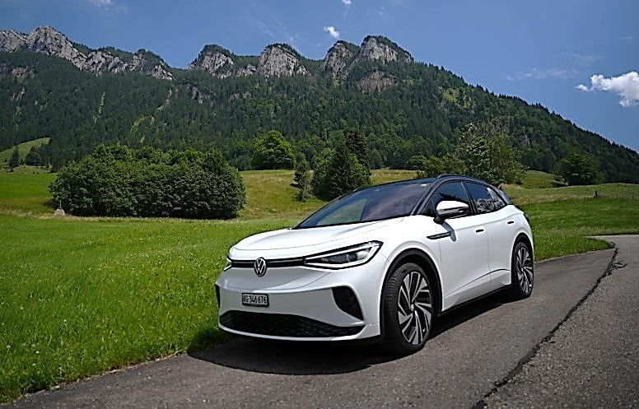

SUGESTED INSTAGRAM POSTS: Samples may be cut-and-pasted into station feed. Please insert call letters or channel, the day/time for your broadcast, and a photo or video clip.

Join “Real Road Adventures” host Jeff Wilson as he navigates the “E-Grand Tour of Switzerland” in a battery powered electric car to explore scenic wonders, multicultural heritage, and sustainable resources in Switzerland and Liechtenstein. TONIGHT [insert local time] on [station].
#realroadadventures #evtravel #europeroadtrip

Jeff Wilson models a stress-free, illuminating, multi-country, multi-cultural European road trip in a battery powered car on Real Road Adventures. Jeff navigates the “E-Grand Tour of Switzerland” and discovers the freedom, safety, and convenience of European travel by EV. For intoxicating, eco-friendly adventure, Jeff tries his hand at kayaking, e-biking, and white-water rafting. And he seeks out opportunities for retreat and self-discovery, on the road less traveled, visiting hidden villages and befriending locals who have discovered the secrets to work-life balance. #realroadadventures #ev #travel #europeroadtrip

TONIGHT [insert time] on [station], Real Road Adventures host Jeff Wilson navigates the “E-Grand Tour of Switzerland” in a battery powered electric car and discovers the freedom, safety, and convenience of European travel by EV. All along the way, Jeff marvels at how Switzerland and Liechtenstein are conserving their natural beauty and fragile ecosystems. For intoxicating, eco-friendly adventure, Jeff plunges into the great outdoors for kayaking, e-biking, white-water rafting and more. #realroadadventures #ev #travel #europeroadtrip

PHOTOS FOR SOCIAL MEDIA: cut and paste this link into a browser
https://www.dropbox.com/sh/wtjq7kcml0pfyrr/AAAt_wzQE3UxaXHEEKF30bL8a?dl=0

VIDEO CLIPS FOR SOCIAL MEDIA: cut and paste this link into a browser
https://www.dropbox.com/sh/ofjssaha0jxt44u/AADMjjFv3hVLCFOJvQi7Q67ra?dl=0

Click a link to open a folder of photos or video clips. Select a file and double click to open. To download the file, click the download arrow [ ↓ ] at top center of the page.

Thanks for promoting Real Road Adventures!
Major corporate support for Real Road Adventures is provided by Volkswagen.

